Registration for 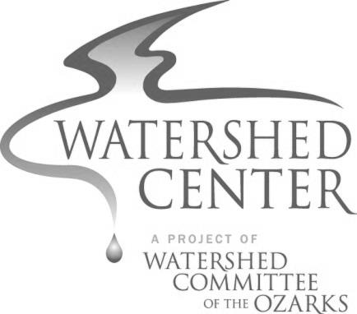
PROJECT WET Workshop
November 22, 2014
The Watershed Center, Springfield MO
9:00 a.m. to 3:30 p.m.

Name: ____________________________________________

Day or Cell Phone: ____________________________________

E-mail: _____________________________________________________

Organization or School:____________________________________________

(If a teacher) Grade Level/Subject: __________________________________

The $25 registration fee covers training and program materials for participants.
Please bring your own lunch.

Approximately 5 days prior to the workshop, you will receive an e-mail reminder and more specifics about the workshop.

***Registration is due by November 19, 2014***

Please make checks payable to Missouri State University

Mail completed form and payment to:

Watershed Committee of the Ozarks
320 North Main Avenue
Springfield, MO 65806

